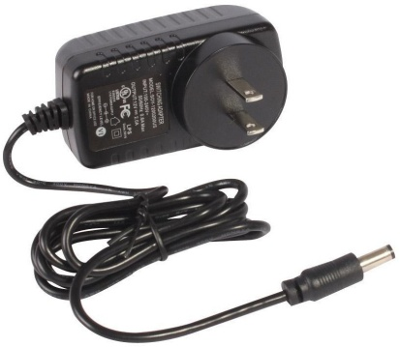

# Output Characteristics

**Input Characteristics**

Rated Voltage : 100 – 240V AC

Variation Range : 90 – 264V AC

Rated Frequency : 50/60Hz Variation Frequency : 47 – 63Hz

Input Current : 0.6A Max. @ Any input AC voltage & output full load

Inrush Current : 35A Max. Cold start @ 240V AC input,

rated output load & 25°C ambient AC Leakage Current : 0.25mA Max. @ 240V AC input

|  |  |  |  |
| --- | --- | --- | --- |
| **Voltage** | **Min. Load** | **Rated Load** | **Output Power** |
| 12V DC | 0.01A | 2A | 24W |

# Combined Load / Line Regulation

|  |  |  |  |  |
| --- | --- | --- | --- | --- |
| **Voltage** | **Min. Load** | **Rated Load** | **Line Regulation** | **Load Regulation** |
| 12V DC | 0.01A | 2A | ± 1% | ± 3% |

**Ripple and Noise** : Under normal voltage & nominal load, the ripple & noise are as follows when measure with Max. Bandwidth of 20MHz & parallel 10µF electrolysis capacitor & 0.1µF ceramic capacitor crossed connect at testing point.

Voltage: +12V DC

Ripple & Noise (Max.): 120mVp-p

Turn on Delay Time : 2S Max. @ 115V AC input and output Max. Load Rise Time : 40mS Max. @ 115V AC input and output Max. Load Hold Up Time : 5mS Min. @ 115V AC input and output Max. Load

Efficiency : Average efficiency 87.4% minimum @ 25%, 50%, 75% & 100% of full-loading and 230V AC input (After warm up 30 minutes). Meet with Energy star level VI. No load input watt ≤ 0.1W

Overshoot : 10% Max. When power supply @ turn on or turn off.

## Environmental Requirement

Operating Temperature : 0°C to 40°C, Full load, Normal Operation

Storage Temperature : -40°C to 85°C

Relative Humidity : 5% (0°C) ~ 95% (40°C) RH, 72Hrs, Full load, Normal operating

## Mechanical Requirement

Enclosure : 82.4mm (L) × 43.7mm (W) × 30.3mm (H)

Input Connector : 2 Pin Input plug

## Outline Dimension

Out Cord : UL1185 18AWG VW-1 80° 300V, FT1 Line with word on the cord

Length: 1.2m.

DC Plug : 5.5mm × 2.1mm × 12mm

# Diagram

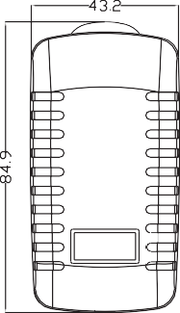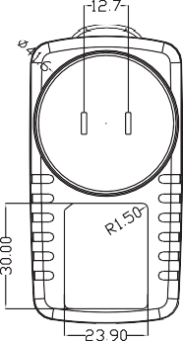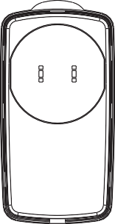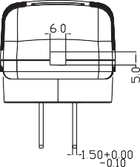

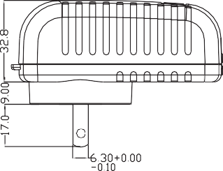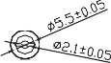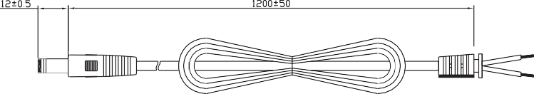Dimensions : Millimetres

|  |  |
| --- | --- |
| **Part Number Table** | |
| **Description** | **Part Number** |
| Regulated AC Power Adapter,12V DC, 2A, 24W | 28-19376 |